1.What is Machine Learning? It provides several modals through which it makes predictions based on the input data. Over Period Of time the data set increases thus, its efficiency also increases in predicting the output.
Three basic types of Machine Learning include: 1. Supervised Learning: Uses labeled data for training. 2. Unsupervised Learning: Identifies patterns in unlabeled data. 3. Reinforcement Learning: algorithm learns from feedback (correct or incorrect).
2.What is Supervised Learning? In this learning we use the labelled data (the inputs are mapped with outputs) to train a modal to make predictions by extracting features of the labelled data. 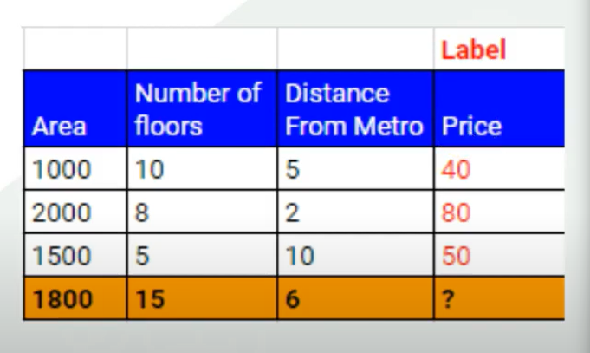
3.What is classification and regression?
For every input there is an output: Output may vary it may be continuous or categorical.
In case, of Continuous types of data we use the Regression.
In case, of Categorical types of data we use the Classification.
Classification: The algorithms are used to solve problems in which the output is categorical.
e.g. “Yes” or “No”, Male or Female etc.
Regression: The algorithms are used to solve regression problems in which there is a definite linear relationship between the input and output variables.
e.g. Weather prediction

